Systemic Support of Students with Disabilities at ELTE University

Mrs. Krisztina Kovács, Head of Centre for Supporting Students with Disabilities, ELTE University
kovacs.krisztina@kancellaria.elte.hu
https://www.elte.hu/en/equal

Legal background in Hungary

The first act dealing specifically with people with disabilities is the Equal Opportunity for Persons with Disability Act (1998). This act has been modified since 1998 several times but the paragraphs on higher education has not changed. This act declares the equality of rights in all areas of social life and education of persons coming within the scope of the act and to ban negative discrimination against them and, where it is absolutely necessary, to apply positive discrimination. It is the right of all students with disabilities to study in higher education institutes according to their abilities and conditions.

Hungary has signed the UN Convention on the Rights of Persons with Disabilities (2006) in 2007.

The new Constitution/Fundamental Law of Hungary (2011) guarantees the fundamental rights to everyone without discrimination and in particular without discrimination on grounds of race, colour, sex, disability, language, religion, political or other opinion, national or social origin, property, birth or any other status.

The new Higher Education act (2011) and its Enacting Clause (2015) give a framework for any university to elaborate its own regulations concerning the inclusion of students with disabilities. Basic regulations:

- Providing equal opportunities and equal access
- The lecturer/teacher has to take into consideration the students’ special needs
- There have to be institutional and faculty disability coordinators pointed out
- Student has right to receive provision according to his/her condition and disability
- Any student can get state financed higher education on all level maximum of 12 semesters – students with disability can get 4 extra semesters.
- Students with disability have to be provided education and evaluation/examination procedure that is suitable for his/her special needs. If it is justified, he/she can be released from studying some subjects or parts of a subject. This release can only be provided if it is based on the special needs of the students and it cannot lead to the exemption of those subjects which are basic requirements for the given field of study/profession.
- Practical subjects can be fulfilled in different ways or can be substituted by theoretical subjects
- Oral exams can be fulfilled written and vice versa
- Release from the obligatory state language examination (part or level)
- Using assistive technology and special equipment during the study and exams
- More preparation time during the exams
- Asking for personal assistants and note-takers

In the Enactment of Higher Education Enrolment (2016) applicants with disabilities can get 40 extra credits because of their special needs if these are proven.
Higher education institutes get 120.000,-HUF (around 400 Euro) after each registered student with disability yearly.

Registration

According to the Higher Education Act and its Enacting Clause those students can be registered with disability who has:
- Visual impairment
- Hearing impairment
- Physical disability
- Speech impairment
- Learning disability:
  - Dyslexia
  - Dysgraphia
  - Dyscalculia
  - Dysorthographia
  - ADHD
  - Behaviour regulation disorder
- Autism-spectrum disorder
- Multiple impairment
From the above list it can be clear that students with chronical illness are not meant being a person with disability.
According to the practice of ELTE University, the registration process starts with contacting the faculty disability coordinators (each Faculty has its own coordinator) and having an appointment with her/him. During or prior to the personal meeting, the student has to send or bring a copy of his/her Certificate of Disability and fill in the Need Assessment form (see in the attachment) which can be downloaded from our website. In most cases these Need Assessment forms are filled in together with the disability coordinator. After the special needs are assessed, an Acknowledgement of Special Needs is written by the coordinator which can be shown to the lecturers/teachers by the student. It is never the coordinator who sends these acknowledgements to the teaching staff; but it is the student who has to take the responsibility to take care of this document.
Those special needs which are in the concern of special educational services are sent to the Disability Centre of ELTE University by the faculty coordinator.

Which bodies are responsible for diagnostics and certification?

There are two options of getting a diagnosis of the disability and a certificate for higher education:
1.) If the special needs are discovered during the compulsory education years or earlier (from birth till the end of secondary education) it is the concern of the Pedagogical assistance services (diagnostics; consultancy; placement). These services can be found in each county and big cities except the Pedagogical Assessment Service of Children with Speech Impairment; the Pedagogical Assessment Service of Children with Visual Impairment; the Pedagogical Assessment Service of Children with Hearing Impairment and the Pedagogical Assessment Service of Children with Physical Disability. These later services can be found only in Budapest and has the whole country as their sphere of action.
2.) If the special needs are discovered or arouse after the compulsory education, there is the Rehabilitation and Social Sectorial Body of the Government Agencies to give the certification.

Table 1: Characteristics of the two types of certificates:

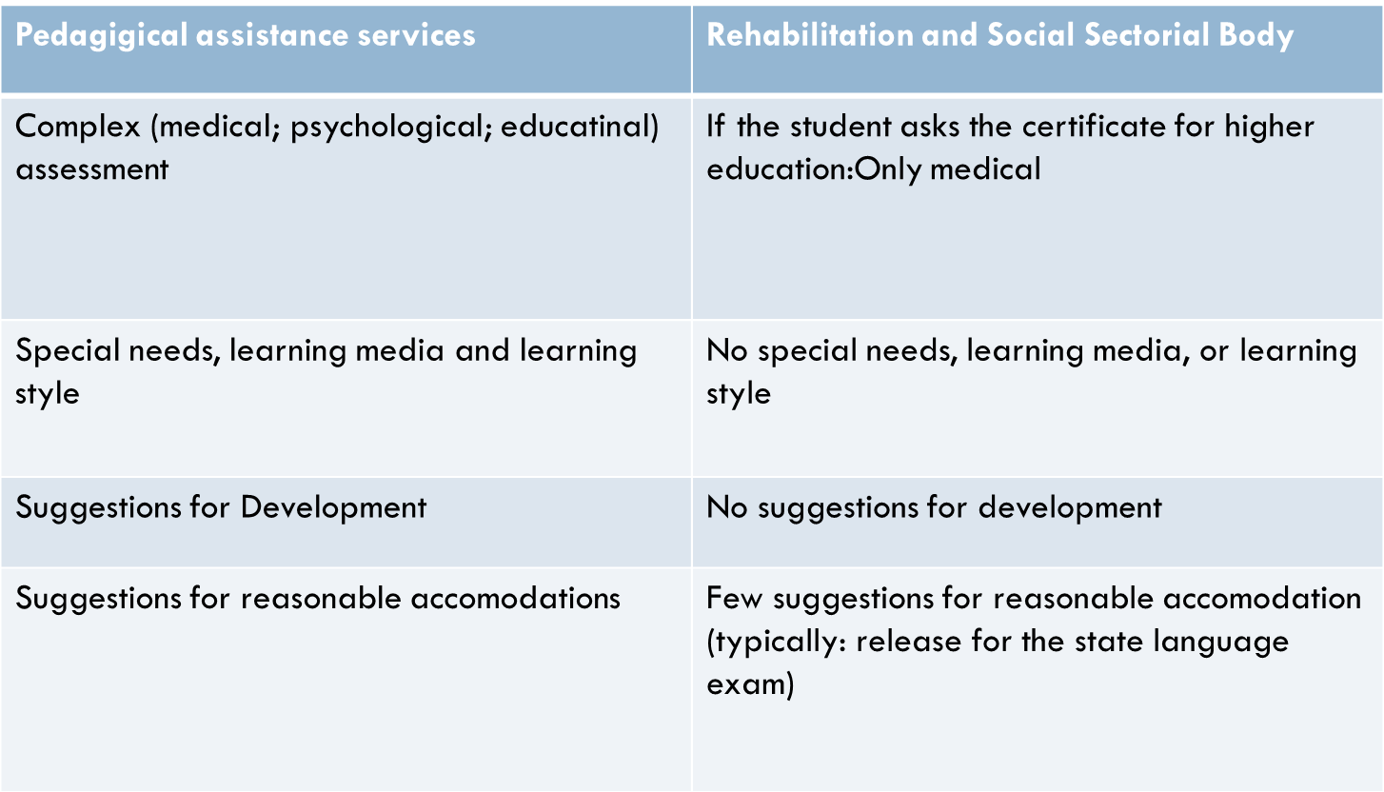

Supporting students with disabilities at ELTE University

ELTE University has been providing service for students with disabilities since 2004. Disability coordinators were appointed in all faculties without training, without special knowledge on disability (exception: Faculty of Special Education), without networking in the first few years. In 2010, the Ministry of Education has asked ELTE to nominate a disability coordinator for the whole university with special education diploma. The faculty and the university level coordinators formulated a team had been working out the registration procedure on a common ground, had established a special equipment rent service, etc. But the services of the different faculties were still not equal in quantity and quality even if the number of students with disabilities had a big growth year by year. The right time for change came in 2015 when – by the initiative of the Chancellor - the Disability Centre was established under the University Student Service. The Disability Centre has 11 faculty coordinators and 6 professionals as members:
- leader – specialist in visual impairment – she is the university disability coordinator as well
- information accessibility specialist – presently there is a blind IT specialist;
- special teacher and rehabilitation instructor of students with visual impairment
- special teacher of students with autism-spectrum disorder;
- special teacher of students with learning disabilities, speech impairment and hearing impairment
- social care giver
The faculty disability coordinators are employed by their own faculties, some of them are teachers, and some of them are other staff and work as disability coordinators part time, as an extra work for extra salary.

Some Statistics
The number of students with disabilities is growing. Here are some figures:
Table 2: Growing number of students with disabilities at ELTE University

Table 3: Type of disability in 2016/17 at ELTE University

Services of the Disability Centre

The Disability Centre - through its professionals – provides special educational support for each student with disability who asks for it. The service can be individual or in a form of group activity. Besides helping students, the Centre is responsible for forming the inclusive policy of the University. It also provides information and support to the teachers and other staff.
Individual services:

- Adaptation of the learning material – digitalization; file converting; tactile graphics; verbal description of the pictures and tables;
- Database on the adapted material, sent to the Central Library
- Orientation and mobility training: teaching routes from home or student hostel to the Faculty; inside and outside the buildings
- Individual training in the use of NEPTUN (electric learning system)
- Providing personal assistants – students are payed, having a contract
- ICT counselling
- Teaching the use of libraries
- Training in learning techniques
- Counselling on activities of daily living
- Helping students with social-communication problems
- Hiring and training of personal assistants and note takers
- Hiring accessible minibus for transportation
- Providing social caregiver for everyday activities
- Information providing to the lecturer staff, to parents, to the students
- Sensibility trainings
- Career counselling
- Accessibility counselling
- Counselling and support for Erasmus students with disability – outgoing and incoming
- Organizing programs
- Having a closed e-mail list for the students with disabilities

Group activities:
- Asperger group
- English speaking group
- Career management course for credits
- Self-awareness course through drama and movement
- Learning techniques course
- Goal ball course –inclusive sport course for credits
- Film club

Services provided by the faculty disability coordinators
- Registering students with disability
- Assessment of special needs
- Writing the acknowledgement of special needs
- Renting special equipment
- Negotiating with teachers of the faculty
- Providing reasonable accommodations concerning the study and organizing them for the exams

National and International Programs
The Disability Centre is committed to spreading knowledge of and to changing attitudes towards disability affairs. Our goal is to give platform to students with disability in all of the programs we organize for the university students, academic and administrative staff, to the public or to the community of people with disability. We aim to reach full participation of the students with special needs with the motto: „Nothing about us without us!”
To achieve our objectives, we regularly organize sensibility programs; disability awareness campaigns; open days; sport events and workshops and we give presentations to different national and international conferences. Our staffs also give lectures in the training program for disability coordinators. ELTE University is the only one that has a barrier-free route planner designed by the Route4u Hungary It can be downloaded from web:
https://route4u.org/maps/ . Applications are available:
iOS: https://itunes.apple.com/hu/app/route4u/id1108929634?mt=8
Android: https://play.google.com/store/apps/details?id=org.route4u.app&hl=en
Some examples of the currently organized programs:
- Open days for secondary school aged pupils with special needs 2016; 2017
- Presentations at Conferences: ICEVI European Conference on Psychology and Visual Impairment 2016, Budapest; Erasmus+ NA Working Group on Special Needs/Persons with Disability 2016, Budapest; Career Day – Premier Kultcafé, Budapest, 2016; Bárczi Faulty of Special Education – How to support students with autism? 2016, Budapest; Coordinators’ National Conference 2016, Budapest; Vocational Rehabilitation Conference, 2017 Budapest; Assistance Dogs for the Inclusive Society, 2017, Budapest; BaGMIVI conference, 2017, Volos, Greece; Slovak Disability Coordinators’ Conference, 2017 Bratislava, Slovakia.
- Sensibility and Disability awareness programs: Faculty of Humanities; Faculty of Law; Faculty of Sciences; International Orientation Day; Student Hostels; ELTE Fest; concert of the Never Give up Gospel choir; Cake fest (selling cakes that were made by the students with disability)
- Sport events: EUSA European University Games 2016 Rijeka: the ELTE Para swimmer students won 5 gold medals and 1 silver medal; Inclusive Sport Day for ELTE students on the occasion of the UNESCO International Day of University Sport; Inclusive goal ball course for credits.

